Assignment 3 – Architectural strategy, evaluation, and documentation
2DV604 - Software Architectures


Luis Eduardo Martín Hernández
lm223sg@student.lnu.se
20050201-T273

Carlos Damas Gómez
cdtk222@student.lnu.se
20050117-T117

29/03/2026

Index

Index 1
Task 1. Conceptualization and Policy Formulation for Observability and Traceability 2
1. Concepts and Contextualization 2
2. Stakeholders and Dependencies 2
3. EasyShop Observability and Traceability Policies 3
4. Systemic Motivation 3
Task 2. Architecturally Significant Requirements (ASRs) 4
1. Introduction to ASRs 4
2. Quality Attribute Scenarios (QAS) 4
Scenario 1: End-to-End Distributed Tracing (Traceability) 4
Scenario 2: Real-time Health Monitoring (Observability) 4
Scenario 3: Accountability of Sensitive Operations (Traceability/Security) 5
3. Functional Requirements for Observability and Traceability 5
4. Role as Architectural Driver 5
Task 3. Alternative Design Concepts Analysis for Observability and Traceability 6
1. Design Concept: Interceptor Pattern (Middleware) 6
2. Design Concept: Sidecar Pattern 7
3. Design Concept: Pull-based vs. Push-based Monitoring 7
4. Reasoning for EasyShop 7
Task 4. Design and Documentation of Strategies for Observability and Traceability 8
1. Discussion of Evaluated Design Concepts and ADRs 8
ADR 1: Distributed Tracing via Application-Level Interceptors 8
ADR 2: Implementation of Standardized Health Check Endpoints 8
2. Architectural Elements and Responsibilities 9
Interface Descriptions 9
3. UML component diagram 10
Task 5. Integration of Security, Observability, and Traceability Mechanisms 11
a. System Responses (The system shall...) 11
b. Response Measures 11
c. Integrated Design Strategy 11
d. Component Model Documentation and Assumptions 11
Task 6. Evaluation of Architecture 14
1. Evaluation Method: Lightweight Architecture Evaluation (LAE) 14
2. Evaluation Results and Argumentation 14
Integrated Scenario (from Task 5): Unauthorized Access Attempt 14
Security Scenario 1: Prevention of Cross-Customer Data Access (From assignment 2) 15
Security Scenario 3: Enforcement of Internal Least Privilege (From assignment 2) 15
Observability/Traceability Scenario 1: End-to-End Distributed Tracing (Traceability) 15
Observability/Traceability Scenario 2: Real-time Health Monitoring (Observability) 15
3. Captured Results: Trade-offs and Risks 16
Identified Trade-offs: 16
Identified Risks: 16
Conclusion: 16
References 17

Task 1. Conceptualization and Policy Formulation for Observability and Traceability

1. Concepts and Contextualization
Observability is the ability to understand the internal state of a system solely by examining its external outputs (logs, metrics, and traces). In the context of EasyShop, this means being able to detect that the PaymentGateway is experiencing high latency or that the Inventory database is nearing its connection limit without needing to debug the live code.
Traceability refers to the capability of following the path of a specific request or data item throughout its entire lifecycle across different components. For EasyShop, this involves tracking an OrderID from the moment a customer clicks "Buy" at a StoreTerminal until the InventoryAndSupplier component confirms the stock update and the OrderProcessing component finalizes the transaction.
- Difference: Observability provides a macro view of the system's health (e.g., "Is the system slow?"), while Traceability provides a micro view of specific transactions (e.g., "Why did this specific order #123 fail?").
- Relationship: Traceability is a fundamental pillar of Observability; without distributed tracing, achieving full observability in a multi-component system like EasyShop is impossible.

2. Stakeholders and Dependencies
- Developers: Depend on traceability to debug complex interactions between components when an error occurs in the distributed environment.
- Operations (SRE): Rely on observability metrics (CPU, memory, response times) to maintain the Availability of the EasyShopServer and ensure the system meets its Service Level Objectives (SLOs).
- Management: Depends on observability to track business-level capabilities, such as the number of successful orders per hour or supplier response times, to make informed business decisions.
- Compliance/Security: Require traceability and audit logs (designed in Assignment 2) to ensure Accountability and verify that no unauthorized modifications were made to financial records in Reporting.

3. EasyShop Observability and Traceability Policies
To ensure a sustainable architecture, the following policies are established:
- What should be observed?
  - Health Status: All components must expose a health check endpoint.
  - External Dependencies: Latency and error rates of ExternalSupplierSystems must be monitored to detect third-party failures.
- What must be traced?
  - Correlation IDs: Every request entering the system must be assigned a unique CorrelationID that persists across all component boundaries (e.g., from OrderProcessing to Inventory).
  - Sensitive Transactions: Any modification to customer data or inventory stock must be traced back to the originating user or API key.

4. Systemic Motivation
- Resilience: High observability allows for faster Fault Detection, reducing the Mean Time to Repair (MTTR) and improving system resilience.
- Accountability: Traceability ensures that every action is non-repudiable, fulfilling the integrity goals of the previously defined security policy.
- Operability and Debt Management: By having clear visibility, the team can identify Architectural Drift early, preventing the accumulation of architecture debt when components start behaving in ways that deviate from the original design.
Prompt 1: "Define the concepts of Observability and Traceability in the context of a distributed e-commerce system. How do they differ in terms of macro-health monitoring versus micro-transaction tracking?".
Prompt 2: "Identify the primary stakeholders for a software system—such as developers, SREs, and management—and explain what specific observability data (metrics, logs, traces) they require to meet business goals.".
Prompt 3: "Suggest a set of mandatory traceability policies for a system handling sensitive financial transactions and inventory updates to ensure non-repudiation and accountability.".

Task 2. Architecturally Significant Requirements (ASRs)

1. Introduction to ASRs
In the EasyShop system, Observability and Traceability are defined as primary Architectural Drivers. They are significant because they represent cross-cutting concerns that affect the interface and logic of every functional component, serving as the foundation for evaluating future deployment strategies.

2. Quality Attribute Scenarios (QAS)

Scenario 1: End-to-End Distributed Tracing (Traceability)
- Source: External Customer.
- Stimulus: Submits a complex purchase request involving multiple IT products and services.
- Artifact: OrderProcessing, InventoryAndSupplier, and SecurityAuditLogger.
- Environment: Normal runtime operation.
- Response: The system generates and propagates a unique Correlation-ID. Each component logs its internal activity linked to this ID.
- Response Measure: The monitoring system must be able to reconstruct the full call graph of the transaction in less than 5 seconds after completion.
- Significance: This forces the design of interfaces that support metadata propagation (Interoperability).

Scenario 2: Real-time Health Monitoring (Observability)
- Source: Internal Monitoring Service.
- Stimulus: A critical component (e.g., Inventory) loses connection to its database.
- Artifact: Affected component and Central Monitoring Dashboard.
- Environment: High-load peak.
- Response: The component’s health endpoint changes to "Unhealthy" and triggers an automated alert.
- Response Measure: The failure must be visible in the central dashboard in less than 30 seconds.
- Significance: Impacts Availability and enables automated recovery tactics such as instance restarts.

Scenario 3: Accountability of Sensitive Operations (Traceability/Security)
- Source: Administrator.
- Stimulus: Attempts to manually modify product prices in the ProductCatalog.
- Artifact: Authorizer, InventoryAndSupplier, and SecurityAuditLogger.
- Environment: Normal operation.
- Response: The Authorizer validates the permissions, and simultaneously, the system records the actor's identity, the old value, the new value, and the Correlation-ID in an immutable log.
- Response Measure: The audit record must be immutable and searchable within 1 second.
- Significance: Ensures compliance with the security policy and guarantees the Integrity of business data.

3. Functional Requirements for Observability and Traceability
- Centralized Log Aggregator: The system shall provide a centralized repository for all components to deposit structured logs.
- Context Propagation Middleware: A software layer shall be implemented in all communication connectors to automate the injection/extraction of the Correlation-ID.
- API Gateway Interceptor: A component at the system edge shall be responsible for assigning a trace ID to every incoming request that lacks one.
- Service Discovery Integration: Observability mechanisms shall integrate with a service registry to automatically discover new instances of deployed components.

4. Role as Architectural Driver
These ASRs serve as the foundation for the Attribute-Driven Design (ADD) process. Any design decision regarding patterns (e.g., Sidecars vs. Interceptors) or deployment infrastructure will be evaluated based on its ability to satisfy these scenarios, ensuring the system does not become a "black box" and minimizing technical debt.

Task 3. Alternative Design Concepts Analysis for Observability and Traceability
This task identifies and evaluates different design concepts (patterns and tactics) to implement the Observability and Traceability policies defined in Task 1. The selection of these concepts is driven by the need to balance Modifiability, Performance, and Security.

1. Design Concept: Interceptor Pattern (Middleware)
This concept involves inserting tracing and logging logic directly into the request-processing pipeline of each functional component (e.g., OrderProcessing or Authenticator).
- Related Tactics: "Log Security Event" (Security) and "Step-by-Step Distributed Tracing" via metadata injection.
- Evaluation:
  - Pros:
    - Performance: because processing occurs within the same process, minimizing network latency compared to external proxies.
    - Context Awareness: Interceptors have direct access to the application’s internal state (e.g., specific CustomerID or OrderAmount), which is crucial for the "Sensitive Transaction Policy".
  - Cons:
    - Modifiability: It introduces a degree of coupling between the business logic and the observability infrastructure.
    - Technology Lock-in: Implementation is language-specific, requiring different versions if EasyShop evolves into a polyglot system.

2. Design Concept: Sidecar Pattern
The Sidecar pattern involves deploying a separate process alongside each service to handle cross-cutting concerns like log aggregation and trace propagation without the main application being aware of it.
- Related Tactics: "Monitor" (Availability).
- Evaluation:
  - Pros:
    - Separation of Concerns: Functional components remain clean and focused only on business logic.
    - Language Agnosticism: The same sidecar (e.g., an Envoy proxy) can be used for any component regardless of its programming language.
  - Cons:
    - Resource Overhead: Each component instance requires an additional process, increasing memory and CPU consumption.
    - Complexity: It adds complexity to the Deployment View and overall system orchestration.

3. Design Concept: Pull-based vs. Push-based Monitoring
- Push-based (e.g., ELK Stack): Components actively send logs/metrics to a central repository.
- Pull-based (e.g., Prometheus): A central monitoring server periodically queries a standard /metrics or /health endpoint on each component.
- Evaluation:
  - Push: Better for Traceability as it captures events in real-time, but can overwhelm the network during high-load peaks (e.g., Black Friday).
  - Pull: More resilient for Observability of system health; if the monitoring server is slow, it doesn't degrade the performance of the functional components.

4. Reasoning for EasyShop
For EasyShop, a hybrid strategy is recommended to satisfy all ASRs:
- Interceptors will be used for Traceability and Security Auditing. Since these require high context (like user roles from the Authorizer), capturing them at the application level ensures the Integrity and Accountability goals from Assignment 2 are met.
- Pull-based Health Checks will be used for Observability. This ensures that the system's "Macro-health" can be monitored without impacting the throughput of sensitive transactions during peak loads.
Prompt 1: "Compare the Interceptor (Middleware) pattern with the Sidecar pattern for implementing distributed tracing. Analyze them based on performance, context-awareness, and technology lock-in.".
Prompt 2: "What are the pros and cons of Pull-based monitoring (e.g., Prometheus) versus Push-based monitoring (e.g., ELK Stack) regarding network overhead during high-load events like Black Friday?".
Prompt 3: "Evaluate the 'Monitor' availability tactic and explain how standardized health check endpoints facilitate automated recovery in a microservices architecture.".

Task 4. Design and Documentation of Strategies for Observability and Traceability

1. Discussion of Evaluated Design Concepts and ADRs
To ensure a sustainable and transparent architecture for EasyShop, we have implemented a hybrid architectural strategy that prioritizes Interoperability and Accountability for traceability, and Availability for observability.
- For Traceability: We selected the Interceptor Pattern over the Sidecar pattern. This decision was driven by the need for high context-awareness. Since our Security Policy requires verifying specific user roles and data access, an application-level interceptor can directly access the Authenticator and Authorizer contexts to bind the Correlation-ID with a verified user identity.
- For Observability: We chose the Pull-based Health Check tactic. This allows the system to remain resilient during high-load periods because the monitoring overhead is managed by the external monitoring service rather than the functional components themselves, preventing performance degradation during peaks.

ADR 1: Distributed Tracing via Application-Level Interceptors
- Status: Accepted.
- Context: EasyShop requires end-to-end traceability to satisfy accountability, and debugging needs across distributed components like OrderProcessing and Inventory.
- Decision: We will implement a TraceInterceptor in every functional component. This interceptor uses the Correlation-ID to store the operations in the SecirutyAuditLogger..
- Consequences: There is a slight increase in internal coupling, but it provides superior performance and better integration with existing security mechanisms.

ADR 2: Implementation of Standardized Health Check Endpoints
- Status: Accepted.
- Context: The system needs real-time health monitoring to ensure Availability and detect failures in external dependencies.
- Decision: Every component must implement a standardized /health API following the "Monitor" tactic. This endpoint reports the component's status.
- Consequences: This simplifies integration with service components and enables automated recovery tactics.

2. Architectural Elements and Responsibilities
The following elements are identified in the Task 4 UML Diagram to realize the framework:
Element | Responsibility
API Gateway | Acts as the system's entry point; responsible for assigning a unique Correlation-ID via the ContextHeader to ensure every request is tracked from the edge.
Component X (Generic) | Represents any functional service (e.g., Reporting); it executes business logic and hosts the HealthProvider and TraceInterceptor.
TraceInterceptor | An internal logic layer within Component X that extracts the Correlation-ID and ensures it propagates to the Security AuditLogger via the AuditRegistry.
Central Monitor | An external infrastructure service that periodically pulls health status from components to detect "Architectural Drift" or service failures.
Security AuditLogger | Acts as the Centralized Log Aggregator, providing an immutable store for all trace and security event data.

Interface Descriptions
- ContextHeader: A data interface provided by the API Gateway and required by Component X to propagate the Correlation-ID.
- HealthProvider: An interface provided by functional components which the Central Monitor consumes (via a Pull-based mechanism) to check system health.
- AuditRegistry: An interface provided by the Security AuditLogger and required by the TraceInterceptor to store tracing events.

3. UML component diagram

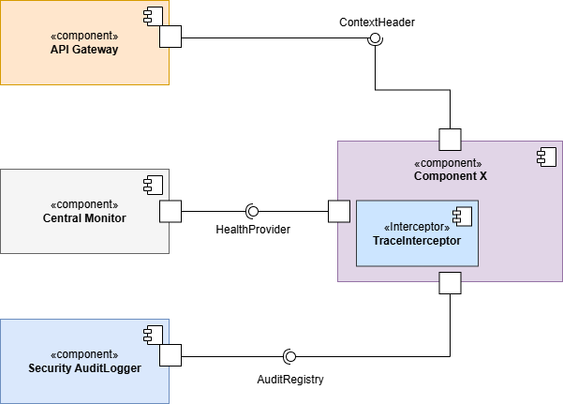

Task 5. Integration of Security, Observability, and Traceability Mechanisms

a. System Responses (The system shall...)
Based on the "Unauthorized Access Attempt" scenario, the integrated architecture behaves as follows:
- The system shall intercept the incoming request at the API Gateway to assign a unique Correlation-ID before any security or business logic is executed.
- The system shall invoke the Authorizer component to verify the actor's permissions, ensuring the Correlation-ID is linked to the security verdict.
- The system shall deny the request immediately if authorization fails, preventing any data leakage from protected components like Reporting.
- The system shall trigger the Authorizer to send an emergency audit record to the Security AuditLogger, containing the identity, denied resource, and the Correlation-ID.
- The system shall update a "security_violation_count" metric in the Authorizer's HealthProvider interface, which is immediately pulled by the Central Monitor.

b. Response Measures
- Security: 100% of unauthorized attempts are blocked.
- Traceability: The full lifecycle of the unauthorized request is reconstructible via Correlation-ID in less than 2 seconds.
- Observability: A security violation alert is visible on the management dashboard within 30 seconds of the event.

c. Integrated Design Strategy
The integration makes the Authorizer "observability-aware". In this scenario, the Authorizer bridges all three disciplines: it enforces Security (Deny), feeds Traceability (by linking the event to the Correlation-ID via the AuditRegistry), and supports Observability (by exposing violation metrics via its HealthAuthorizer interface).

d. Component Model Documentation and Assumptions
- Component Model: As shown in the Task 5 UML Diagram, the Central Monitor now monitors every component via individual health interfaces (e.g., HealthAuthorizer, HealthReporting). The Authorizer serves as the central security filter, requiring the AuditRegistry from the Security AuditLogger and providing AccessControl to components like Reporting and OrderProcessing.
- Assumptions:
  - The API Gateway is the strictly enforced single entry point for all external traffic.
  - The Security AuditLogger utilizes asynchronous writing to ensure logging does not add latency to the "Access Denied" response.
  - The Central Monitor pulling frequency is configured to meet the 30-second visibility requirement.

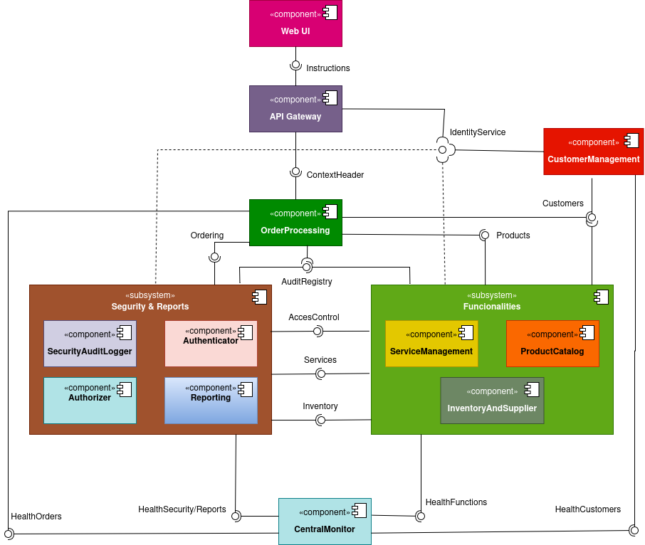

Task 6. Evaluation of Architecture

1. Evaluation Method: Lightweight Architecture Evaluation (LAE)
To evaluate the proposed architecture, we conducted a Lightweight Architecture Evaluation (LAE), applying the core principles of the Architecture Tradeoff Analysis Method (ATAM). This qualitative method goes beyond a simple walkthrough by not only tracing the execution flow of specific Quality Attribute Scenarios (QAS) through the architectural design, but also analyzing how different quality attributes interact with each other.
The evaluation focuses on the integration of the Security mechanism (from Assignment 2) with the new Observability and Traceability framework. By doing so, we aim to provide clear argumentation and evidence that the identified components and interfaces satisfy the required response measures. Furthermore, this method helps us explicitly identify architectural trade-offs (e.g., the impact of strict traceability on performance) and discover potential technical or operational risks, ensuring that the adopted design decisions are "good enough" to minimize these risks.

2. Evaluation Results and Argumentation

Integrated Scenario (from Task 5): Unauthorized Access Attempt
- Argumentation: When an unauthorized actor attempts to access a protected resource, the API Gateway assigns a unique Correlation-ID. The Authorizer intercepts the request and denies access based on the lack of permissions, fulfilling the security requirement. Simultaneously, the Authorizer acts as a stimulus source: it sends an emergency log to the Security AuditLogger via the AuditRegistry interface and increments a violation metric in its HealthAuthorizer interface, which is pulled by the Central Monitor.
- Trade-off & Risk: By centralizing the security, traceability, and observability responses within the Authorizer, we trade Modifiability (the component becomes more complex) for high Cohesion and Context-Awareness. The identified risk is that the Authorizer could become a performance bottleneck under high load.
- Conclusion: Satisfied. The architecture ensures these concerns are coupled in the execution flow. The risk is mitigated by assuming the Security AuditLogger uses asynchronous writing to avoid adding latency to the denial response.

Security Scenario 1: Prevention of Cross-Customer Data Access (From assignment 2)
- Argumentation: An authenticated customer attempting to access another's data is blocked by the Authorizer using Role-Based Access Control (RBAC).
- Trade-off: To support non-repudiation and advanced traceability, the system links every security denial to a traceable request ID. This is a trade-off between Security/Traceability and Performance, as logging every failed attempt consumes additional storage and network bandwidth compared to simply dropping the request.
- Conclusion: Satisfied. The integrated design successfully allows administrators to identify potential brute-force or crawling patterns, accepting the minor storage overhead as a necessary cost.

Security Scenario 3: Enforcement of Internal Least Privilege (From assignment 2)
- Argumentation: The Authorizer ensures employees can only access interfaces permitted by their specific role. Any attempt to escalate privileges triggers an immutable log entry in the Security AuditLogger.
- Trade-off: Using a Standardized Format Policy (JSON) for these alerts allows them to be automatically parsed by the Central Monitor in real-time (Interoperability). However, the trade-off is that JSON parsing has a higher computational overhead (Performance) compared to using a lightweight binary format.
- Conclusion: Satisfied. The integrity of business data is preserved and verifiable, and the processing overhead is deemed acceptable for internal administrative interactions.

Observability/Traceability Scenario 1: End-to-End Distributed Tracing (Traceability)
- Argumentation: The architecture utilizes the "Step-by-Step Distributed Tracing" tactic. By using the API Gateway as the root of the trace and TraceInterceptors in every component, the Correlation-ID is propagated across all internal API calls.
- Risk: The primary risk of injecting TraceInterceptors into every component is the increase in internal coupling and a slight latency penalty added to every internal network call.
- Conclusion: Satisfied. Reconstructing the call graph in less than 5 seconds is achievable because all logs are centralized using the Correlation-ID as a partition key. The performance risk is manageable as long as the logging mechanisms remain strictly asynchronous.

Observability/Traceability Scenario 2: Real-time Health Monitoring (Observability)
- Argumentation: We implemented the "Monitor" tactic through a Pull-based mechanism. The Central Monitor queries the HealthProvider interface of each component. If InventoryAndSupplier loses its database connection, its health status changes to "Unhealthy," which is detected in the next polling cycle.
- Trade-off & Risk: This design heavily favors Availability over strict Real-time Observability. The trade-off is that we avoid network flooding during high-load peaks by controlling the frequency from the Central Monitor. The associated risk is that transient failures lasting less than the polling interval (e.g., a 10-second database drop when polling every 30 seconds) might go completely undetected.
- Conclusion: Satisfied. The design prioritizes system stability during traffic spikes, making it a "good enough" solution for the EasyShop environment.

3. Captured Results: Trade-offs and Risks
While the Lightweight Architecture Evaluation (LAE) confirms that the proposed architecture successfully satisfies the prioritized security, observability, and traceability scenarios, the ATAM-based approach helped us explicitly discover the following architectural interactions and potentially problematic decisions (risks):

Identified Trade-offs:
- Coupling vs. Context-Awareness: Using the Interceptor Pattern introduces a higher degree of internal coupling and a slight latency penalty on every internal request compared to a Sidecar approach. However, this trade-off was accepted to guarantee the necessary context-awareness for strict Security Accountability.
- Availability vs. Real-Time Observability: The decision to use a Pull-based monitoring mechanism prevents the system from network flooding during high-load peaks, prioritizing overall system Availability. The accepted trade-off is a reduction in strict real-time observability.

Identified Risks:
- Performance Bottleneck: Centralizing the security auditing and trace logging into the SecurityAuditLogger creates a potential performance bottleneck or single point of failure under heavy load. This risk is partially mitigated by the assumption that the component uses asynchronous writing.
- Undetected Transient Failures: Relying on the CentralMonitor polling every 30 seconds introduces the operational risk that short-lived component failures (e.g., a transient database drop lasting 10 seconds) might go completely undetected between cycles.

Conclusion:
No architecture is without flaws or technical debt. However, based on this evaluation, the integration of the Authorizer with the tracing and monitoring infrastructure provides a high degree of Resilience and Accountability. The identified risks are manageable within the current business constraints, making this architectural design "good enough" to meet EasyShop's goals.

References
Software Architecture in Practice (Bass, Clements, & Kazman): https://www.oreilly.com/library/view/software-architecture-in/9780136886099/
- Used for: Implementing the Lightweight Architecture Evaluation (LAE) based on ATAM.
Building Microservices, 2nd Edition (Sam Newman): https://samnewman.io/books/building_microservices_2nd_edition/
- Used for: Evaluating the Sidecar pattern and service-to-service communication.
OpenTelemetry Documentation (Distributed Tracing): https://opentelemetry.io/docs/concepts/signals/traces/
- Used for: Designing the TraceInterceptor and ContextHeader propagation logic.
Prometheus Overview (Pull-based Monitoring): https://prometheus.io/docs/introduction/overview/
- Used for: Justifying the Pull-based Health Check tactic for system stability.
Architecture Decision Records (Joel Parker Henderson): https://github.com/joelparkerhenderson/architecture-decision-record
- Used for: Structuring the ADRs for Interceptors and Health Endpoints.
Designing Data-Intensive Applications (Martin Kleppmann): https://dataintensive.net/
- Used for: Analyzing the impact of asynchronous audit logging on system performance

